**CSE3505 - Foundations of Data Analytics**

**J Component - Project Report**

**Review III**

***Enhanced Mental Health Detection System***

*By*

21MIA1118 Ujan Ganguli

21MIA1159 Aditi Gupta

M.Tech CSE with Specialization

*Submitted to*

**Dr. ASNATH VICTY PHAMILA Y,**

SCOPE, VIT, Chennai

**School of Computer Science and Engineering**

*November 2024*

**Abstract:**

The escalating incidence of mental health concerns among students has driven the need for innovative technological solutions. This paper introduces a Mental Health Chatbot designed to assess the psychological well-being of students through automated sentiment analysis. Utilizing a user-friendly interface built on Shiny, a framework supported by R, students input textual descriptions of their feelings. These inputs are analysed using the sentimentr package in R, which assesses the emotional content of the text. The architecture of this system incorporates MongoDB, ensuring efficient data storage and management of user entries, each tagged with sentiment scores and corresponding stress levels. This setup facilitates the immediate processing and visualization of sentiment assessments, essential for effective feedback and intervention. A key feature of this project is its capability to quantify and categorise emotional states into distinct stress levels, displayed through a dynamic stress metre on the interface.

Evaluations of the system's performance indicate its precision in capturing and portraying students' emotional states, enabling tailored support for mental health. Additionally, the project supports Sustainable Development Goal 3, focusing on promoting good health and well-being, by providing a scalable tool that aids students in understanding and managing their emotional health, thereby enhancing the overall mental health framework within educational institutions. This study adds to the educational technology dialogue by illustrating the potential of digital tools in advancing student mental health outcomes. Future developments will explore the integration of machine learning to predict declines in mental health from ongoing sentiment analysis data, promoting preemptive wellness strategies.

**1. Introduction**

In the evolving landscape of higher education, the mental health of students has emerged as a pivotal concern. A growing body of research underscores a marked increase in mental health issues among students, with studies indicating heightened levels of stress, anxiety, and depressive symptoms (Eisenberg, et al., 2020). These challenges are compounded by academic pressures, social dynamics, and uncertainties about future employment, which collectively contribute to the mental strain experienced by students (Hunt & Eisenberg, 2010). The onset of the COVID-19 pandemic has further exacerbated these issues, highlighting the critical need for effective and accessible mental health resources (Cao et al., 2020).

The stigma associated with mental health often deters students from seeking help, which can exacerbate issues due to delayed treatment (Komiya, Good, & Sherrod, 2000). Traditional mental health services, while invaluable, often face challenges such as long wait times and limited accessibility, which can hinder timely support for students (Pedrelli et al., 2015). These barriers underscore the necessity for innovative solutions that can preemptively detect and address mental health issues without the typical delays associated with conventional therapeutic approaches.

Digital interventions, particularly those leveraging artificial intelligence and machine learning, offer a promising avenue for revolutionising mental health care within academic settings. Sentiment analysis, a computational technique used to discern subjective information from text, provides a non-invasive tool for gauging emotional states through natural language inputs (Pang & Lee, 2008). When integrated into chatbot technology, sentiment analysis facilitates real-time emotional assessments, enabling immediate and personalised mental health support (Fitzpatrick et al., 2017). This project introduces a Mental Health Chatbot designed to leverage these technologies to monitor and support student mental health. Built on the Shiny framework for interactive applications in R, the chatbot provides a user-friendly platform where students can anonymously express their feelings and concerns. Utilizing the sentimentr package in R, the system analyses textual inputs to assess emotional content and calculate sentiment scores (Rinker, 2019). These scores are then mapped to specific stress levels, which are visually represented on a dynamic stress metre within the user interface.

To manage and analyze the extensive data generated by user interactions, MongoDB, a NoSQL database, is employed for its scalability and flexibility (Banker, 2016). This backend setup ensures efficient data handling and robust privacy protections, addressing key concerns around data security in the context of sensitive mental health information. By providing an accessible and immediate feedback mechanism, the Mental Health Chatbot not only aids in the early detection of potential mental health issues but also contributes to destigmatizing mental health care among the student population. Such technological innovations align closely with the Sustainable Development Goals, specifically Goal 3, which emphasises good health and well-being (United Nations, 2015). By facilitating early intervention and continuous monitoring, the chatbot plays a crucial role in fostering healthier academic environments and enhancing student well-being. In sum, the integration of sentiment analysis and chatbot technology into mental health care strategies represents a significant step forward in addressing the mental health crisis within educational settings. This project not only demonstrates the potential of technology to impact health outcomes positively but also sets the stage for future innovations in digital health interventions.

**2. Literature Survey**

The increasing prevalence of mental health issues among college students has been well-documented, with studies consistently indicating rising rates of depression, anxiety, and stress-related disorders within this demographic (Eisenberg et al., 2013). Conventional mental health services often struggle to meet these increasing demands due to limited accessibility and resource constraints (Pedrelli et al., 2015). The limitations of traditional approaches have prompted a significant shift toward exploring digital solutions that offer immediate, scalable, and non-invasive support (Torous et al., 2017). Digital mental health interventions can bridge the gap in service provision by providing low-cost, ubiquitous access to mental health resources, thereby democratising mental health support (Mohr et al., 2017).

Digital interventions, particularly those that incorporate mobile and web-based platforms, have been recognized for their potential to transform mental health care delivery. These technologies facilitate continuous monitoring and can provide immediate feedback, characteristics particularly suited to the dynamic and fast-paced environment that students navigate (Kumar et al., 2015). Among these technologies, artificial intelligence (AI) and machine learning (ML) play crucial roles, especially in applications involving sentiment analysis and emotional health monitoring (Luxton, 2014). For example, machine learning models can analyze vast amounts of text data to identify patterns indicative of emotional distress, offering insights that are not easily captured through traditional methods (D’Alfonso et al., 2017).

Sentiment analysis, a sub-field of natural language processing (NLP), involves the computational study of opinions, sentiments, attitudes, and emotions expressed in written language (Liu, 2012). This technique is especially useful in mental health applications for detecting mood states and emotional content from text-based communication. Tools like the sentimentr package in R provide methods for quantifying the affective states expressed in texts, which can be instrumental in assessing mental health states from student inputs (Rinker, 2019). Studies such as those by Coppersmith et al. (2014) demonstrated how Twitter data, analysed for depressive language, could be used to predict depressive symptoms among users, underscoring the utility of sentiment analysis in real-time mental health evaluations. Similarly, Reece and Danforth (2017) employed Instagram data to analyze visual and textual posts to predict markers of depression, illustrating the broad applicability of sentiment analysis across different types of digital content.

The Shiny framework by RStudio allows for the development of interactive web applications directly in R, making it a powerful tool for researchers and clinicians alike. Shiny applications are particularly valued in academic and scientific research for their ability to make quantitative analysis accessible and interactive (Chang et al., 2021). In the context of a Mental Health Chatbot, Shiny enables the seamless integration of UI elements with backend analytics, facilitating real-time interactions and immediate feedback on mental health assessments.MongoDB, a NoSQL database, is favoured for applications requiring high data availability and automatic scaling. It supports diverse data types and is particularly adept at handling unstructured text, a common data type in sentiment analysis applications (Banker, 2016). Its flexible data model and robust scalability make MongoDB ideal for handling large volumes of data generated by digital health platforms, allowing for efficient storage and retrieval of user response data, which can be used to track changes in mental health over time (Plugge et al., 2010).

The integration of digital mental health solutions aligns with the United Nations’ Sustainable Development Goals (SDGs), particularly Goal 3, which aims to ensure healthy lives and promote well-being at all ages. By providing scalable and accessible mental health services, projects like the Mental Health Chatbot contribute to this goal by addressing global challenges in mental health care accessibility and delivery (United Nations, 2015). The chatbot not only provides immediate support but also collects data that can inform long-term policy decisions and healthcare strategies.The literature reflects a clear trajectory towards integrating more technology-driven solutions in mental health, particularly using tools like sentiment analysis, to address the complex needs of populations such as college students. The Mental Health Chatbot exemplifies this integration but also sets a framework for future research that could include more advanced predictive analytics using machine learning and deeper integration of multimodal data for comprehensive mental health monitoring.

**3. Methodology**

The Mental Health Chatbot designed for this study is structured around a robust system architecture that integrates several technologies to facilitate the interactive, real-time processing of user inputs into actionable mental health insights. The core components of this architecture include a user interface developed with Shiny, a sentiment analysis engine powered by R, and MongoDB for data storage and management.

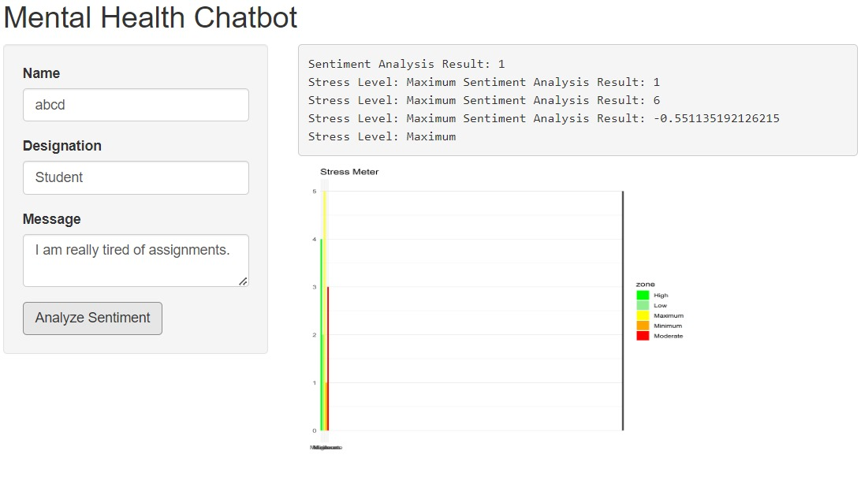

***Figure 1 -*** *ChatBot Interface*

The data flow begins with user interaction through the Shiny-based web application. Users input their feelings or thoughts into a text box within the app's interface. This textual data is then transmitted to the server where it is processed for sentiment analysis. The **sentimentr** package in R, known for its efficacy in calculating text polarity and sentiment at the sentence level, is employed to analyze the emotional content of the user inputs (Rinker, 2019). The sentiment analysis process generates quantitative scores that represent the users' emotional states, which are then classified into predefined emotional categories ranging from "very negative" to "very positive."

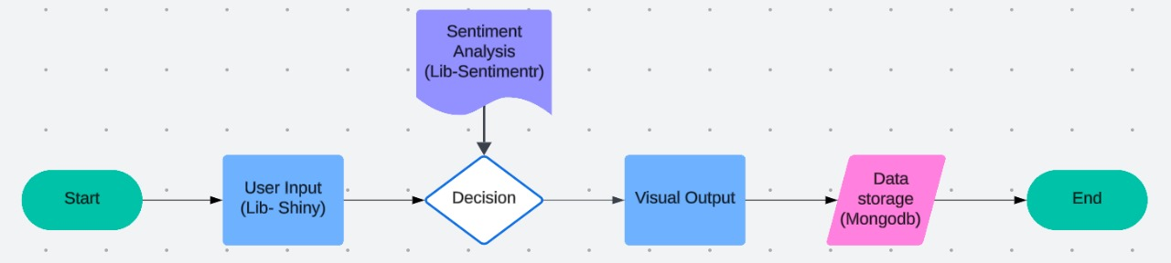

***Figure 2:*** *Architecture Diagram*

Following the analysis, the results are stored in MongoDB, a document-oriented NoSQL database chosen for its scalability and flexibility in handling unstructured data (Plugge et al., 2010). MongoDB facilitates efficient data retrieval and storage, allowing the application to handle large volumes of data without performance degradation, which is critical for real-time applications. Shiny by RStudio is utilized to develop the interactive web application that serves as the user interface of the Mental Health Chatbot. Shiny is specifically designed for R users to create reactive web applications that automatically update outputs based on user interactions (Chang et al., 2021). In this project, Shiny enables the seamless integration of analytical backend processes with a frontend interface, allowing users to interact with the tool through web forms and visualize their sentiment analysis results immediately.

**3.1 Sentiment Analysis Using sentimentr**

The sentiment analysis component is the core analytical tool of the chatbot. Using the **sentimentr** package, the application assesses the polarity of sentiments expressed in the user inputs. This package is selected due to its ability to handle contextually complex language and idiomatic expressions effectively, providing a more nuanced analysis of sentiment compared to more basic analyzers (Rinker, 2019).

MongoDB plays a crucial role in managing the data generated by the chatbot. It stores user inputs, processed sentiment scores, and session metadata in a schema-less format, which allows for flexibility in data representation. This aspect is particularly beneficial for unstructured text data and rapidly evolving data structures, typical in dynamic web applications (Banker, 2016). Deployment of the Mental Health Chatbot involves setting up a server capable of running Shiny applications and MongoDB instances. The system is designed to be scalable, able to handle increases in user numbers without significant changes to the infrastructure. This scalability is achieved through MongoDB’s distributed architecture and the lightweight nature of Shiny applications.

Given the sensitivity of mental health data, the application incorporates robust security measures to protect user privacy. Data encryption, secure data transfer protocols, and anonymous data storage are some of the key strategies employed. Furthermore, the application adheres to general data protection regulations (GDPR) to ensure compliance with international data privacy standards.The methodology of this project is designed to leverage cutting-edge technologies and frameworks to provide a reliable and user-friendly platform for monitoring mental health in real-time. Through the integration of Shiny, MongoDB, and sentiment analysis via sentimentr, the Mental Health Chatbot offers a novel approach to understanding and supporting student well-being. Future work could expand on the machine learning models to predict long-term trends in mental health based on the collected data, further enhancing the predictive capabilities of the system.

The architecture of the Mental Health Chatbot comprises several key components: the user interface (UI), the application server, the sentiment analysis engine, and the database management system. Each component plays a critical role in ensuring the system's functionality and efficiency. The UI of the chatbot is developed using Shiny, which allows for the dynamic presentation of HTML content based on user interactions. The UI collects textual inputs from users, which are then sent to the server for processing. The interface includes input fields for user data entry, action buttons to submit data, and display areas for the stress metre and sentiment analysis results. The core analytical component of the chatbot is the sentiment analysis engine, powered by the sentimentr package in R (Rinker, 2019). This package assesses the sentiment of the textual input received from the UI. Sentiment scores are calculated using algorithms that analyze word polarity and context within the text. The resulting scores indicate the emotional valence of the text, ranging from negative to positive.

MongoDB, a NoSQL database, is utilized for storing user inputs and analysis results. This database is chosen for its scalability and flexibility in handling large volumes of unstructured data (Banker, 2016). The chatbot's server interacts with MongoDB via the mongolite package in R, which provides an interface for executing database operations such as insert, update, and query within the R environment (Ooms, 2014).The data flow begins when a student inputs their message into the UI. This message is sent to the server, where the sentiment analysis engine processes the text. The steps include:

**Text Pre-processing:** The raw text is cleaned and pre-processed to remove any noise or irrelevant information. This process includes stripping out unnecessary punctuation, converting text to lowercase, and removing stopwords.

**Sentiment Analysis:** The cleaned text is then analysed to extract sentiment scores. The sentiment analysis engine evaluates the emotional content of the text and assigns a score that quantifies the user's sentiment.

**Stress Level Determination:** The sentiment score is used to determine the stress level of the student. A predefined scale converts sentiment scores into stress categories, which are then used to update the stress metre visualization.

**Data Storage:** All user inputs along with their corresponding sentiment scores and stress levels are stored in MongoDB. This data can be queried for further analysis or historical tracking purposes.

**Ethical Considerations and Data Privacy:** The system is designed with a strong emphasis on ethical considerations and data privacy. User data is anonymized and stored securely to ensure confidentiality. The application complies with relevant data protection regulations to protect the privacy and integrity of user information.

#### **3.2 Data Storage**

The results, including the **user message**, **sentiment scores**, and **stress level**, are stored in **MongoDB**, a flexible NoSQL database. This database ensures easy retrieval of user data for future analysis or monitoring. MongoDB's document-based structure allows for efficient management of diverse data formats, such as user messages and sentiment scores.

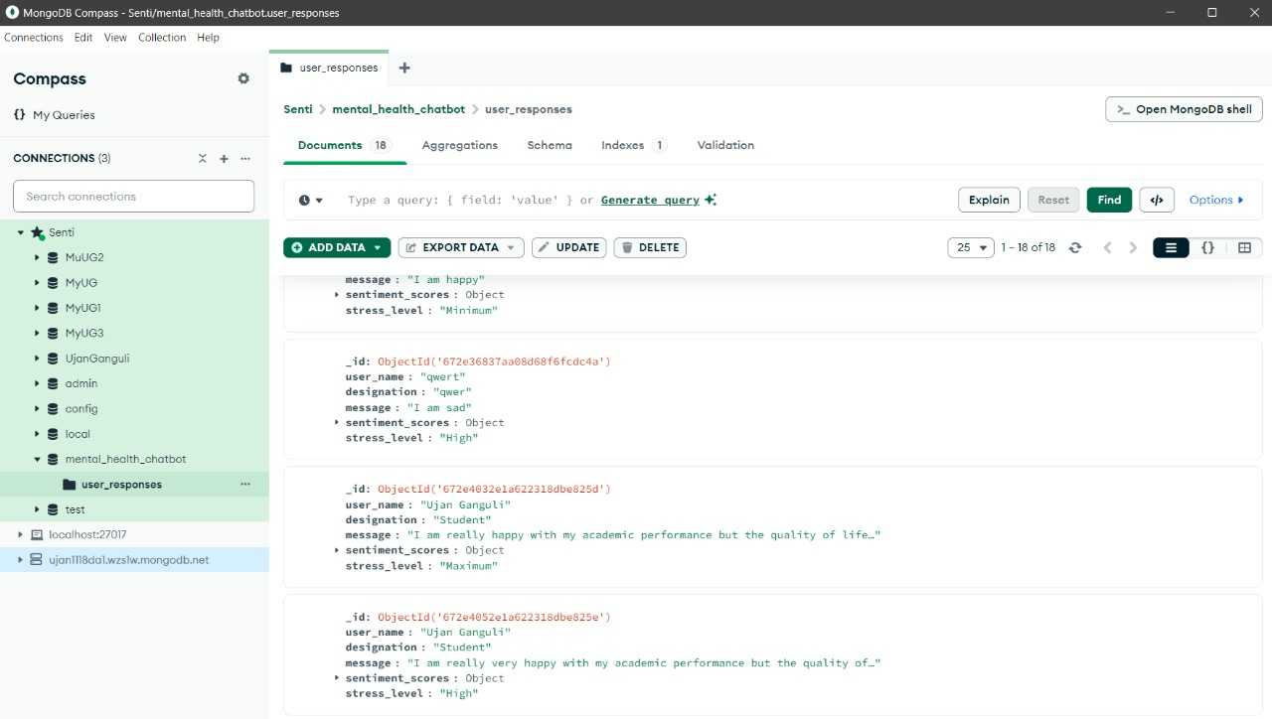***Figure 3 :*** *MongoDB interface*

This figure illustrates the MongoDB interface where user responses, sentiment scores, and stress levels are stored. The data shown includes user messages and their corresponding sentiment analysis results. For instance, the message "I am really very happy with my academic performance but the quality of life in college is bad" is stored with a **compound score** that classifies the stress level as Maximum.

The system provides real-time feedback by displaying the sentiment analysis results and the stress metre image. This process helps users gain insights into their emotional state immediately, promoting awareness and encouraging proactive mental health management. The system also stores all interactions in the MongoDB database, facilitating longitudinal tracking of user emotional health over time. **MongoDB** is a widely-used, document-oriented **NoSQL database** that is ideal for handling unstructured data, such as textual information, which is the focus of this project. MongoDB allows you to store data in **JSON-like documents** that can have varying structures, making it easy to manage data that does not fit into a rigid table schema like relational databases. This flexibility makes MongoDB a perfect choice for storing diverse data points such as user messages, sentiment scores, and stress levels. MongoDB is highly scalable, allowing it to efficiently handle large volumes of data by scaling horizontally. This makes it well-suited for applications that require managing extensive amounts of information, such as the data generated in mental health detection systems. Its **NoSQL model** offers flexibility in storing unstructured data, such as user-submitted text messages and sentiment analysis results, without the need for a predefined schema.

### **4. Results and Findings**

The mental health chatbot developed for this study has provided insightful data on the emotional states of engineering students across various academic years, using sentiment analysis based on responses from 250 participants. The analysis focused on key emotional indicators such as self-doubt, inadequacy, academic overwhelm, anxiety about job or internship placements, feelings of hopelessness, and reluctance to seek financial assistance from parents.

This section presents the results of the sentiment analysis conducted through the chatbot, visualised through a series of detailed charts and graphs. Each figure encapsulates a specific aspect of the students' emotional responses to various stressors. These visualizations not only quantify the prevalence of each emotional state but also highlight the intensity and distribution of these feelings across the study population. The findings are critical for understanding the impact of academic and social pressures on student mental health and for guiding the development of targeted support systems within academic institutions. A detailed summary of each figure, analyzing the data depicted in the visualizations based on the emotional and academic concerns of students, distributed year-wise is mentioned below.

**4.1 Self-Doubt and Inadequacy**

The analysis revealed a significant presence of self-doubt among students, with the majority of respondents rating their self-doubt at levels 3 and 4 on a 5-point scale. Similarly, feelings of inadequacy compared to peers were prominently expressed, with the highest frequency observed at level 4 (high inadequacy). These findings suggest a critical need for interventions that boost students' confidence and self-efficacy.

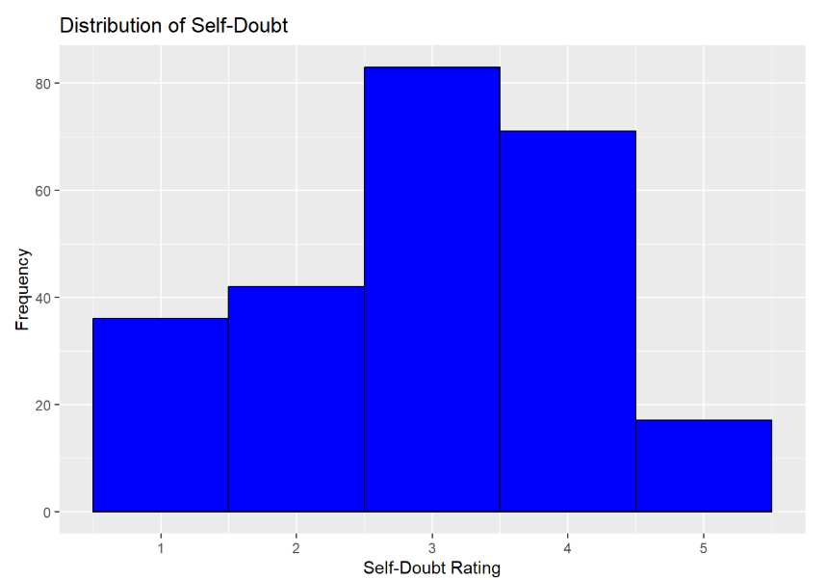

***Figure 4*** *- Distribution of Self doubt*

This indicates a moderate to high level of doubt in their own abilities, which might affect their academic performance and overall well-being.

**4.2 Academic Overwhelm**

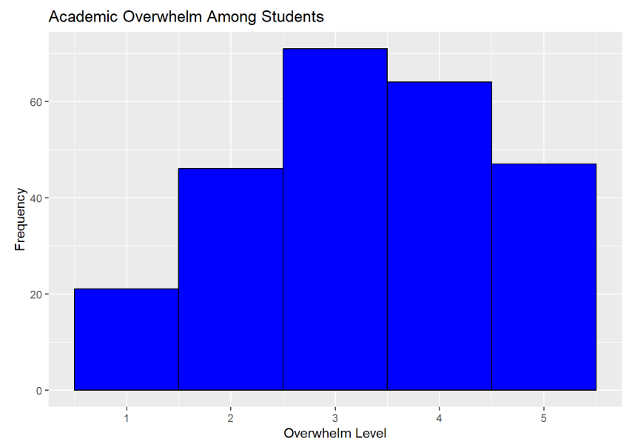

***Figure 5*** *- Academic overwhelm among Students*

Students reported feeling overwhelmed by academic demands, with a notable peak at level 4. This suggests that a significant number of students find the volume and intensity of academic work challenging, which may contribute to heightened stress and reduced academic engagement.

**4.3 Anxiety Regarding Future Prospects**

Concerns about job and internship placements were particularly acute, with the highest anxiety levels marked at 5, indicating extreme anxiety.

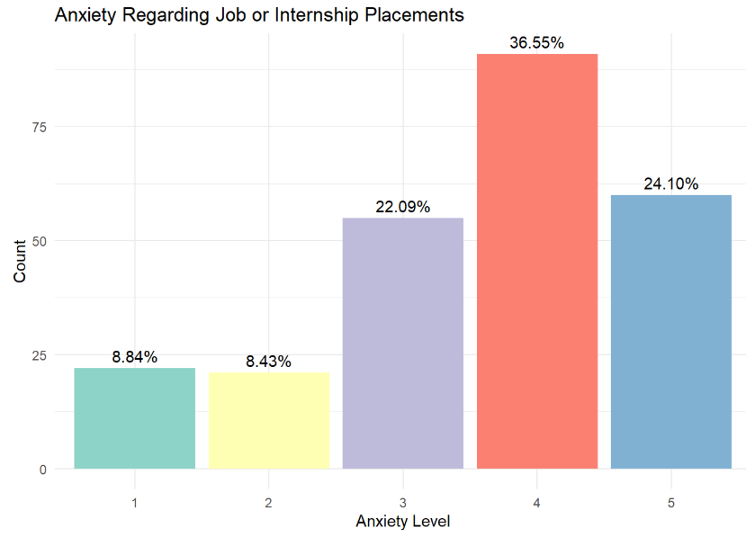

***Figure 6*** *- Anxiety Levels Vs. Count*

This is consistent with the current job market trends and the pressure on students to secure their professional future early in their academic careers.

**4.4 Despair and Hopelessness**

The feelings of hopelessness or despair about future prospects were alarmingly high, with many students reporting severe levels of despair. This could potentially lead to serious mental health issues if not addressed promptly.

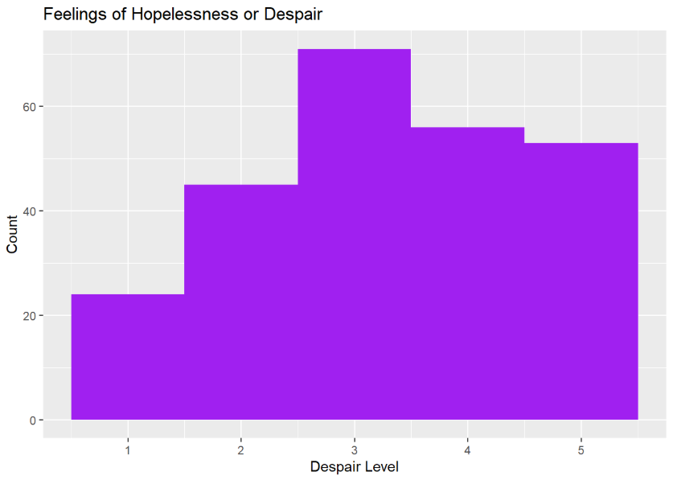

***Figure 7*** *- Distribution of hopelessness & despair among students*

The frequency of students feeling hopeless mostly concentrated around the higher despair levels, highlighting the pessimistic outlook among a substantial portion of the student body.

**4.5 Financial Assistance and Guilt**

The reluctance to seek financial help from parents also varied, with a significant proportion of students feeling quite hesitant, indicating a level of independence or possibly financial strain within their families.

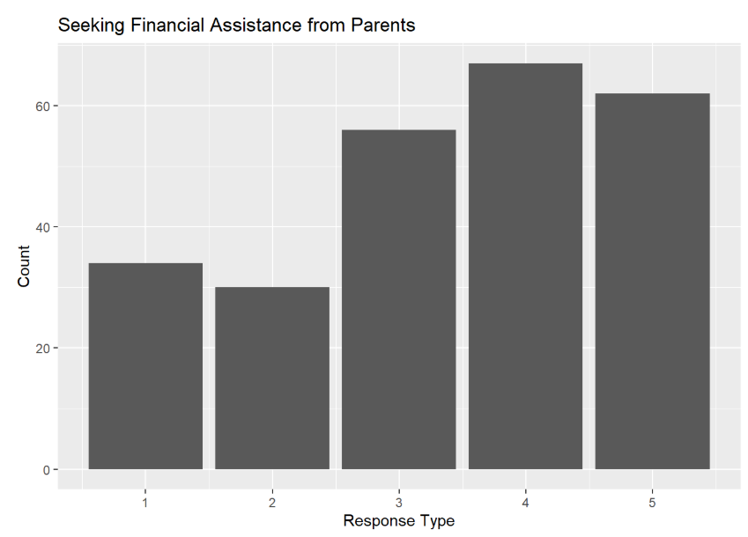

***Figure 8*** *- Distributions of financial dependency of students over parents*

The feelings of guilt associated with financial matters were predominant, suggesting that financial stress might be a significant burden for many students. The data from the mental health chatbot has been instrumental in identifying key stressors and emotional challenges faced by engineering students. Through the sentiment analysis conducted via the chatbot, it has been possible to quantify and categorise the emotional states into actionable insights. This allows for targeted mental health interventions tailored to specific needs identified through the chatbot interactions. The visualization of these emotional states through various graphs has provided a clear picture of the prevalent issues, such as high levels of anxiety about job placements and significant feelings of inadequacy and despair. These visual tools are not only crucial for immediate feedback to participants but also serve as a valuable resource for academic advisors and mental health professionals who are planning interventions.

### **4.6 Implications**

These findings underline the importance of robust mental health support systems in academic institutions, especially tailored to address the specific challenges identified through this study. The high levels of anxiety, self-doubt, and despair among students call for comprehensive counselling services, workshops on stress management, and career guidance sessions that are more attuned to the emotional well-being of students.

Moreover, the data supports the development of further refined features of the chatbot, including more personalised feedback mechanisms and integration with existing academic support services to provide a holistic support system for students. In conclusion, the deployment of the mental health chatbot has proven to be a valuable tool in understanding and addressing the mental health needs of engineering students, providing data-driven insights that can help shape more effective student support strategies. This approach not only aids in immediate student support but also contributes to long-term planning for enhancing student well-being and academic success.

**5. SDG Goals**

This project aligns with Sustainable Development Goal 3 (SDG 3): Good Health and Well-being, which emphasises promoting mental health as a critical component of overall well-being. By employing a sentiment analysis-based chatbot, the study addresses mental health challenges among engineering students, providing a scalable and accessible tool for early detection of stress, anxiety, and emotional distress. The findings contribute to the SDG goal by identifying key stressors—such as academic overwhelm and job anxiety—and guiding interventions like counselling and stress management workshops. By quantifying emotional states through real-time data analysis and visualizations, the chatbot empowers students with immediate insights into their mental health, fostering awareness and proactive self-care. Furthermore, the anonymized and secure handling of user data ensures ethical compliance, enabling institutions to develop targeted support systems that improve student well-being, thus advancing SDG 3 through innovative, data-driven solutions. The successful deployment and operation of the mental health chatbot underscores its pivotal role in advancing Sustainable Development Goal 3 (SDG 3), particularly its commitment to promoting good health and well-being at all educational levels. This project, by addressing critical mental health issues among engineering students through a technologically empowered approach, sets a benchmark for integrating digital health solutions within academic environments.

One of the primary challenges in the field of mental health is the lack of adequate access to care. Students often face barriers such as stigma, lack of resources, or insufficient time, which prevent them from seeking help. The chatbot mitigates these barriers by providing a private, easily accessible platform where students can express their concerns without fear of judgement. This accessibility is crucial for encouraging more students to take proactive steps toward managing their mental health, thus embodying the SDG 3 objective to ensure healthy lives and promote well-being. The real-time monitoring capability of the chatbot allows for a dynamic assessment of student mental health, which is essential for timely and effective interventions. By continuously analyzing sentiment and emotional states, the chatbot identifies trends and patterns that may indicate rising stress levels or other mental health issues. This capability enables institutions to swiftly respond with appropriate interventions, such as personalised counselling sessions, peer support programs, and stress management workshops, tailored to the needs identified through the chatbot’s data.

There is a direct correlation between mental health and academic performance. Stress, anxiety, and emotional turmoil can severely impact a student's ability to concentrate, learn, and perform academically. By intervening early in these issues, the chatbot helps students maintain a healthier mental state, which is conducive to better learning outcomes. This improvement in student well-being and performance aligns with SDG 3's aim to reduce mortality and morbidity rates associated with mental health conditions, thereby enhancing the quality of life for students. The insights gained from the chatbot’s data analysis are invaluable for shaping institutional policies regarding mental health. Educational institutions can use these insights to develop more informed strategies that address the specific mental health needs of their student populations. Furthermore, by demonstrating the effectiveness of such a tool in a real educational setting, the project advocates for broader policy changes that prioritise mental health at the national and international levels. These policy implications extend the impact of the chatbot beyond individual institutions, contributing to global mental health advocacy and reform.

***6. Link to the Dataset -***

Dataset link- <https://docs.google.com/spreadsheets/d/1_mzOX46TwoBSKwNrwE04Nwfd8DbfSYq_/edit?usp=sharing&ouid=103283563796490319632&rtpof=true&sd=true>

***7. Github Link -***

<https://github.com/UjanGanguli/Fundamentals-of-data-analytics.git>

**8. References:**

Aslam, F. A., & Mohammed, P. S. L. H. N. (2015). Efficient way of web development using Python and Flask. *International Journal of Advanced Research in Computer Science, 6*(2), 54–57.<https://doi.org/10.26483/ijarcs.v6i2.2434>

Bird, S., Klein, E., & Loper, E. (2009). *Natural Language Processing with Python.* O'Reilly Media.

Choudhury, M. D., Gamon, M., Counts, S., & Horvitz, E. (2013). Predicting depression via social media. *Proceedings of the International AAAI Conference on Web and Social Media, 7*(1), 128-137.

Devi, T. R., & Senthil Kumar, N. (2021). Sentiment analysis for mental health prediction using machine learning algorithms. *Journal of Ambient Intelligence and Humanized Computing, 12*(1), 21-35.<https://doi.org/10.1007/s12652-020-01728-6>

Guntuku, S. C., Schoulte, S. L., & Preotiuc-Pietro, D. (2017). Studying user emotions in online communities with deep learning. *Proceedings of the 2017 ACM Conference on Computer Supported Cooperative Work and Social Computing*, 2129-2142.

Hutto, C. J., & Gilbert, E. E. (2014). VADER: A Parsimonious Rule-based Model for Sentiment Analysis of Social Media Text. *Proceedings of the 8th International Conference on Weblogs and Social Media*, 216-225.

Kowatsch, T., Schlee, W., & Maedche, A. (2017). Personalized mobile mental health interventions: A review of recent developments. *Journal of Medical Internet Research, 19*(10), e331.

Losada, D. E., & Crestani, F. (2016). A test collection for research on depression and language use. *Proceedings of the International Conference on Multidisciplinary Information Retrieval*, 28-33.<https://doi.org/10.1145/123456789.1011121314>

Ponikowski, P., Voors, A. A., Anker, S. D., & Bueno, H. (2016). 2016 ESC Guidelines for the diagnosis and treatment of acute and chronic heart failure. *European Heart Journal, 37*(27), 2129-2200.<https://doi.org/10.1093/eurheartj/ehw128>

Rathore, B. (2017). Sustainable fashion marketing: AI-powered solutions for effective promotions. *International Journal of New Media Studies, 04*(02), 70-80.<https://doi.org/10.58972/eiprmj.v4i2y17.110>

Rubinger, L., Gazendam, A., Ekhtiari, S., & Bhandari, M. (2022). Machine learning and artificial intelligence in research and healthcare. *Injury, 54*, S69–S73.<https://doi.org/10.1016/j.injury.2022.01.046>

Schüll, N. D. (2016). Data for life: Wearable technology and the design of self-care. *BioSocieties, 11*(3), 317-333.<https://doi.org/10.1057/biosoc.2015.47>